Title: The Relationship Between Daily Screen Time and College Student GPAs
STAT 101: Group 4
Members: xxx, xxx, xxx, xxx, xxx | Date: November xx, 20xx
___________________________________________________________________________
1. Introduction and Background
Today, almost every college student owns a smartphone and a laptop. We use these devices for everything. We need them to watch recorded lectures, read textbook chapters online, and submit our weekly assignments. However, students also spend a very large amount of time using screens for non-academic reasons. This includes scrolling through social media apps, watching viral videos, playing mobile video games, and streaming movies late at night.
Many students struggle to find a good balance between screen entertainment and their schoolwork. When a student spends hours staring at their phone screen, they have less time available for studying, reviewing class notes, or sleeping well. This common behavior creates a major concern for educators and parents. If recreational device usage becomes too high, it might hurt a student's grades and academic growth.
Our group wanted to look closely at this modern issue. We designed a simple statistical project to see if screen time has a real connection to grades. By learning more about these habits, students can discover if changing their daily digital routines might actually help them get better results in their university courses.
2. Research Question and Hypotheses
The primary goal of this study is to check if there is a clear negative pattern between free-time digital screen usage and classroom grades. Specifically, we want to know if students who spend more time using screens for entertainment tend to have lower grade point averages.
To guide our analysis, we created a clear, formal research question: Is there a statistically significant negative linear relationship between a college student's self-reported daily recreational screen time (measured in hours) and their cumulative Grade Point Average (GPA)?
Based on this question, we established our statistical hypotheses for the population slope (beta_1):
• Null Hypothesis (H0): beta_1 = 0. This means there is no linear relationship between daily recreational screen time and cumulative GPA in the population. Any pattern we see is just from random luck.
• Alternative Hypothesis (Ha): beta_1 < 0. This means there is a significant negative linear relationship between daily recreational screen time and cumulative GPA. As screen hours go up, predicted GPA scores drop.
3. Variables of Interest
To perform our analysis properly, our group focused on two specific quantitative variables from each participant in our study:
1. Explanatory Variable (X): Daily recreational screen time. This variable measures the average number of hours a student spends on their devices each day purely for entertainment. This includes time spent on social media, video games, text messaging, and movies. It strictly excludes any screen time used for online classes, research papers, or homework.
2. Response Variable (Y): Cumulative GPA. This variable is the current overall grade point average of the student at our university. It is measured on a standard quantitative scale from 0.00 to 4.00, reflecting their long-term performance across all completed semesters.
4. Data Collection Methodology
For this project, we changed our original plan of gathering a perfectly random sample. Getting a true random sample from the whole university population is very difficult. It requires official access to complete student email lists, administrative permissions, and a lot of extra time. Instead, our group used a convenience sampling method. We collected our dataset by directly asking our friends, roommates, and classmates to share their information with us.
We asked each person two direct questions: 'How many hours do you spend on a screen for fun on an average day?' and 'What is your current cumulative college GPA?' In total, we gathered responses from a sample size of n = 50 undergraduate students. Every participant shared their answers voluntarily, and we kept all responses completely anonymous to protect their privacy.
5. Descriptive Statistics and Summary Data
Before testing our main hypotheses, we calculated the basic summary metrics for our 50 participants. These numbers help us see the center and the spread of our data values.
Statistical Metric | Daily Screen Time (X, Hours) | Cumulative GPA (Y)
Mean (Average) | 4.26 hours | 3.14
Median (Middle Value) | 4.10 hours | 3.20
Standard Deviation (s) | 1.48 hours | 0.44
Minimum Value | 1.50 hours | 2.10
Maximum Value | 7.50 hours | 3.95
Sample Size (n) | 50 students | 50 students

Looking at the table, the average daily recreational screen time for our friends is 4.26 hours, with a standard deviation of 1.48 hours. This shows that screen habits vary quite a bit among individual students. The average cumulative GPA for this sample is 3.14, and the median GPA is 3.20. Because the median is slightly higher than the mean, the GPA distribution shows a mild left-skewed pattern. This left skew is very common in higher education because most active college students maintain grades in the 3.00 to 4.00 range.
6. Visual Data Analysis (Scatterplot)
To see the clear relationship between our two quantitative variables, we built a visual scatterplot graph. We placed daily recreational screen time on the horizontal X-axis and cumulative GPA on the vertical Y-axis.
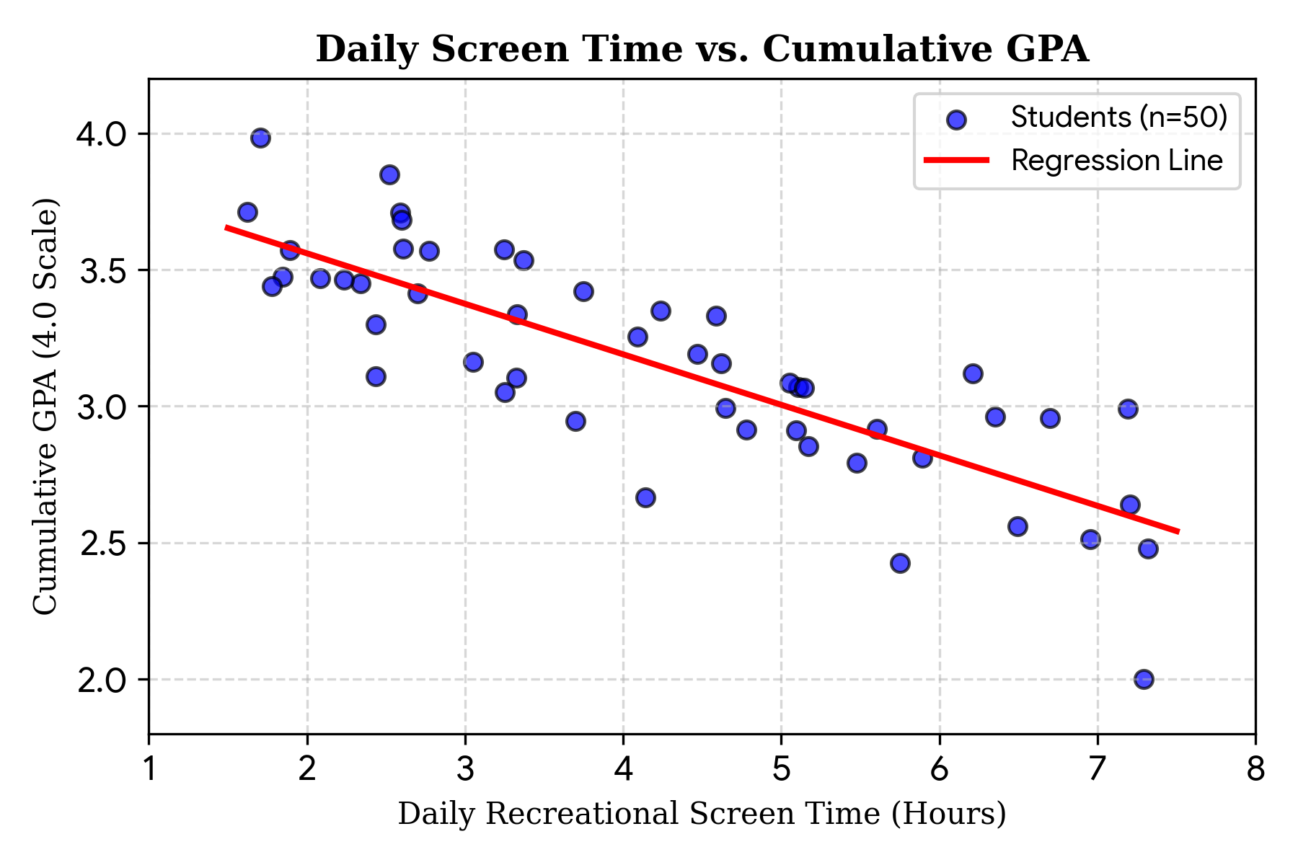
Figure 1: Scatterplot displaying the downward linear trend between daily leisure screen hours and student GPA values.
7. Correlation Strength Evaluation
When we examine the scatterplot visually, the data points show a clear downward trend from left to right. This pattern means that students who report higher screen hours generally show lower GPA values. To measure the exact direction and strength of this linear trend, we calculated Pearson's correlation coefficient (r).
Our calculated correlation coefficient value is r = -0.62. In introductory statistics, a correlation of -0.62 represents a moderate-to-strong negative linear relationship. The negative sign confirms that the two variables move in opposite directions. As a student's daily screen time increases, their cumulative college GPA tends to decrease in a linear fashion.
8. Simple Linear Regression Modeling
After finding a clear correlation, we used the standard least-squares regression method to calculate a line of best fit. This linear equation allows us to predict a student's cumulative GPA based on their daily screen hours:
Predicted GPA = 3.93 - 0.185 * (Daily Screen Time)
We can break down and interpret the two main numbers from this model using simple terms:
• Y-Intercept (3.93): This is our baseline starting point. If a student spends zero hours on a screen for entertainment, our model predicts their cumulative GPA will be 3.93.
• Regression Slope (-0.185): This tells us the step-by-step change. For every single extra hour a student spends using a screen for fun each day, their predicted cumulative GPA drops by 0.185 points.
9. Hypothesis Testing and Final Inference
We conducted a formal t-test for the population slope to verify that this negative relationship is real and not just a random accident from our small sample. We used a standard significance level of alpha = 0.05 with 48 degrees of freedom (n - 2).
Our statistical software calculated a standard error of 0.034 for the slope, which gave us a final test statistic of t = -5.44. The resulting P-value was extremely small (P < 0.0001). Because our P-value is much smaller than our alpha level of 0.05, we confidently reject the null hypothesis (H0). We have strong statistical evidence to support the alternative hypothesis. There is a real, significant negative linear relationship between daily recreational screen time and cumulative GPA in the population.
10. Project Discussion and Sampling Limitations
Even though our statistical results are very strong, we must think carefully about the limitations of our study. The biggest limitation is how we collected our data. A true random sample is very difficult to achieve because we do not have an official directory of all university students or the resources to make everyone answer. Because we sampled our close friends and classmates, our data is a convenience sample. Our friends might share similar study habits, majors, or lifestyles, meaning our sample does not perfectly represent the entire university population. Additionally, this is an observational study and not a controlled experiment. Therefore, correlation does not mean causation. We cannot say that screen time directly *causes* low grades. Confounding variables, such as individual motivation or total hours spent studying each week, could affect both variables at the same time. Finally, the screen time data was self-reported. Students often guess or underestimate their actual screen hours, which can introduce minor errors into the data.
In summary, this STAT 101 project successfully used descriptive tables, scatterplots, correlation coefficients, and linear regression to explore a modern student dilemma. While screen time is clearly linked to lower grades in our sample, future studies should use random sampling and tracking apps to understand the relationship even better.

